A. ICMP Protocol
- Display filter: `icmp`
- Purpose: ICMP (Internet Control Message Protocol) is used for network diagnostics and error reporting. Tools such as ping use ICMP Echo Request and Echo Reply messages.
- How to capture: Start a capture, open Command Prompt, run `ping 8.8.8.8`, and then apply the `icmp` display filter.
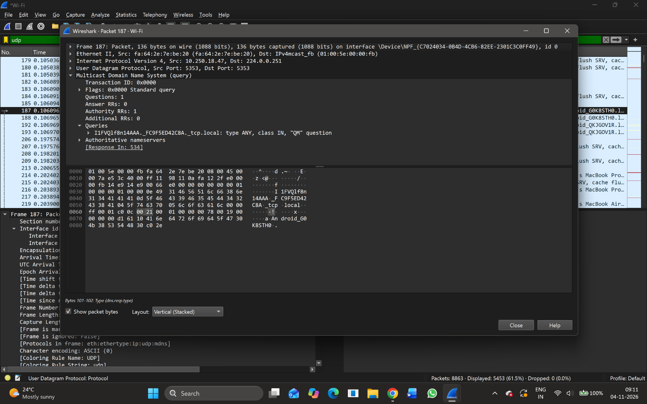
Figure A1. Supplied screenshot: ICMP display filter with no matching packets.
Result: The ICMP filter was applied, but no ICMP packets are visible in the supplied capture. A new capture while generating ping traffic is required to complete the ICMP observation.

B. TCP Protocol
- Display filter: `tcp`
- Purpose: TCP (Transmission Control Protocol) is connection-oriented and provides reliable, ordered delivery of data using acknowledgements and retransmission when required.
- Observed packet: Frame 202
- Frame length: 210 bytes
- Capture length: 210 bytes
- Interface / encapsulation: Wi-Fi interface; Ethernet II
- Observed IP and transport details: The packet details screenshot identifies IPv4 traffic from 10.250.22.55 to 149.154.167.99 and TCP traffic using destination port 443 (HTTPS).
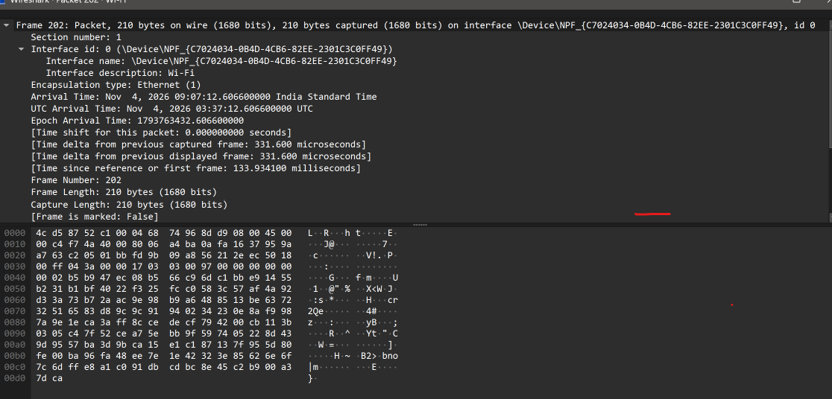
Figure B1. Frame 202: Wireshark frame summary and packet bytes.
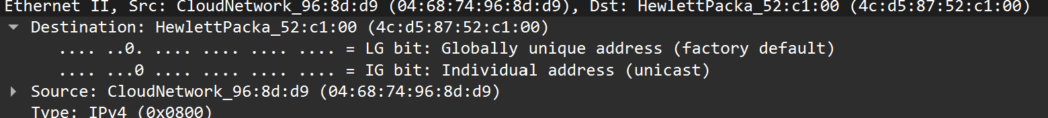
Figure B2. Ethernet II header showing source and destination MAC addresses.
Result: The selected packet is a TCP packet. The supplied capture reports a frame size of 210 bytes.

C. TCP Length (tcp.len)
- Display filter: `tcp.len > 0`
- Purpose: The tcp.len field represents the number of bytes of TCP payload carried in a segment. The filter `tcp.len > 0` displays TCP packets that contain at least one byte of TCP payload.
- Observed payload: One supplied TCP details screenshot explicitly reports `TCP payload (120 bytes)` and `TCP Segment Len: 120`.
- TCP length: 120 bytes (as displayed in the supplied packet details).
- How to verify: Apply `tcp.len > 0`, select a matching packet, expand Transmission Control Protocol, and inspect the segment length / TCP payload details.
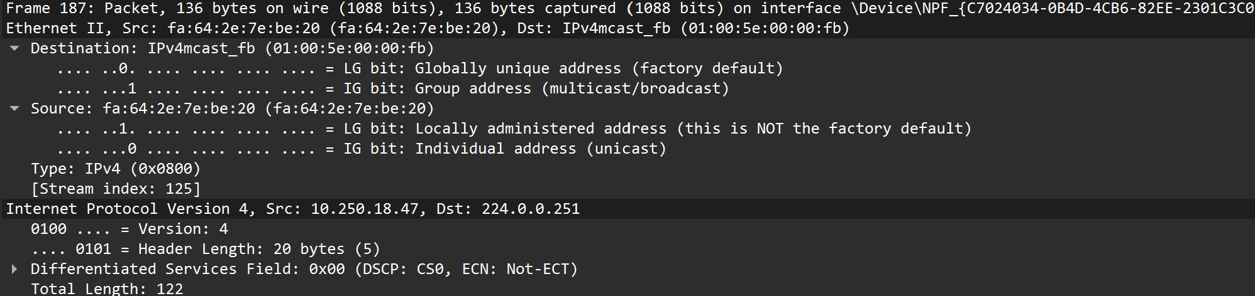
Figure C1. TCP details showing a 120-byte TCP payload.
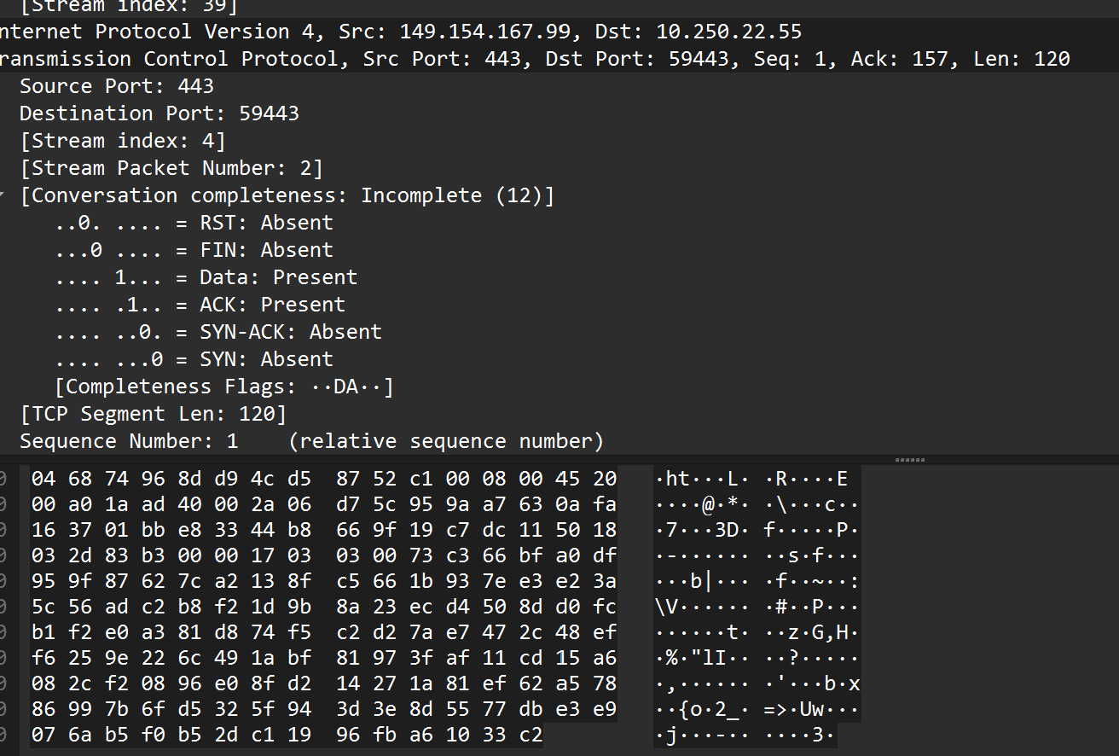
Figure C2. Additional TCP packet details and bytes.
Result: The supplied packet details show a TCP payload length of 120 bytes. This is the TCP data length, not the total Ethernet frame length.

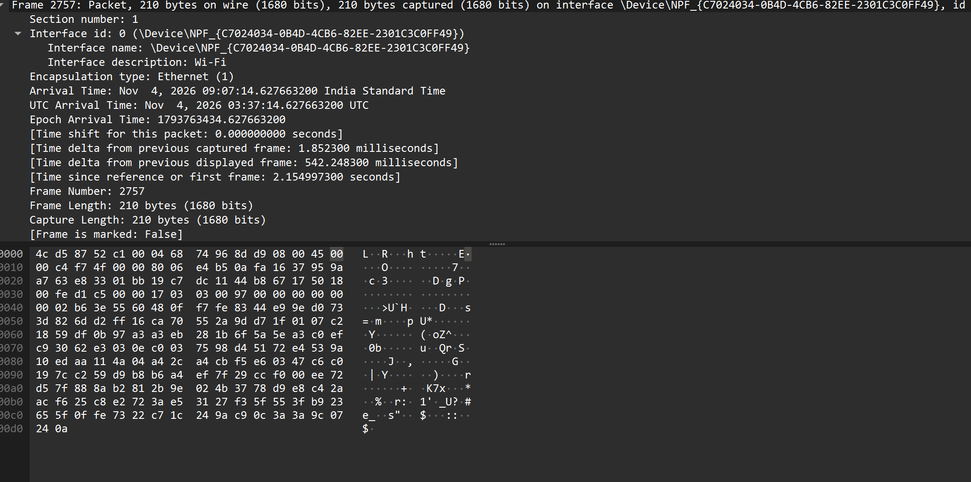

D. UDP Protocol
- Display filter: `udp`
- Purpose: UDP (User Datagram Protocol) is connectionless. It sends datagrams without establishing a connection and does not provide TCP-style delivery acknowledgements or retransmission.
- Observed packet: Frame 187
- Frame length: 136 bytes
- Source and destination ports: 5353 → 5353
- Protocol / service: Multicast DNS (mDNS), which uses UDP port 5353 for local-network service and device discovery.
- Destination IP: 224.0.0.251 (IPv4 multicast address used by mDNS).
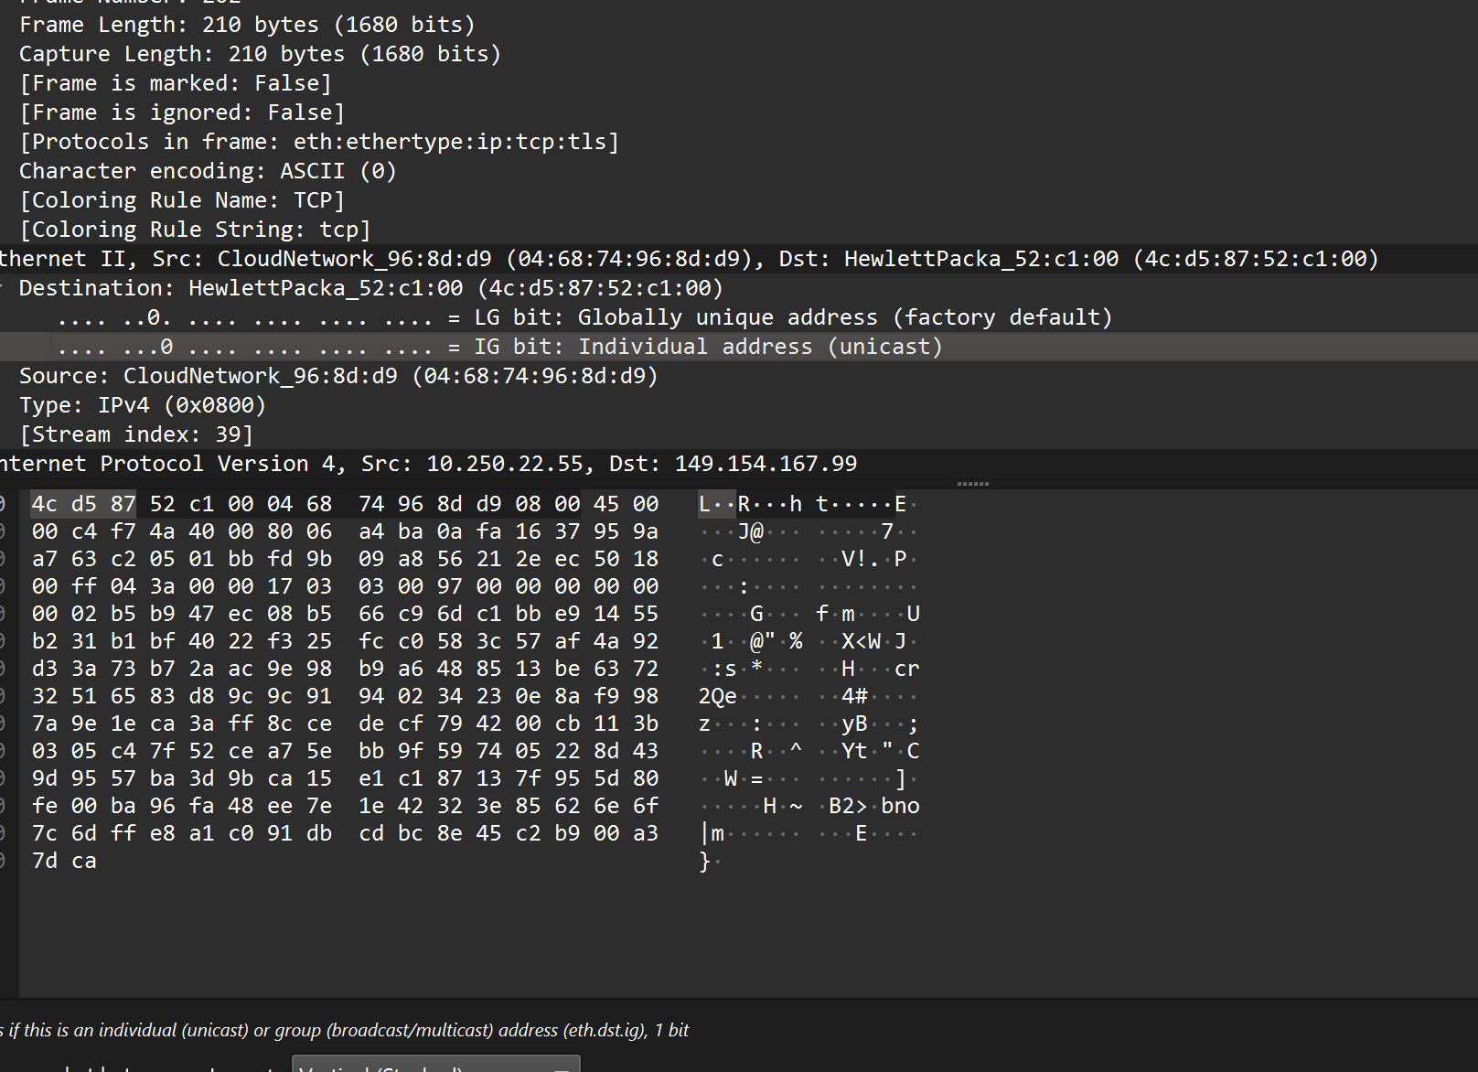
Figure D1. Frame 187: UDP packet decoded as an mDNS query.
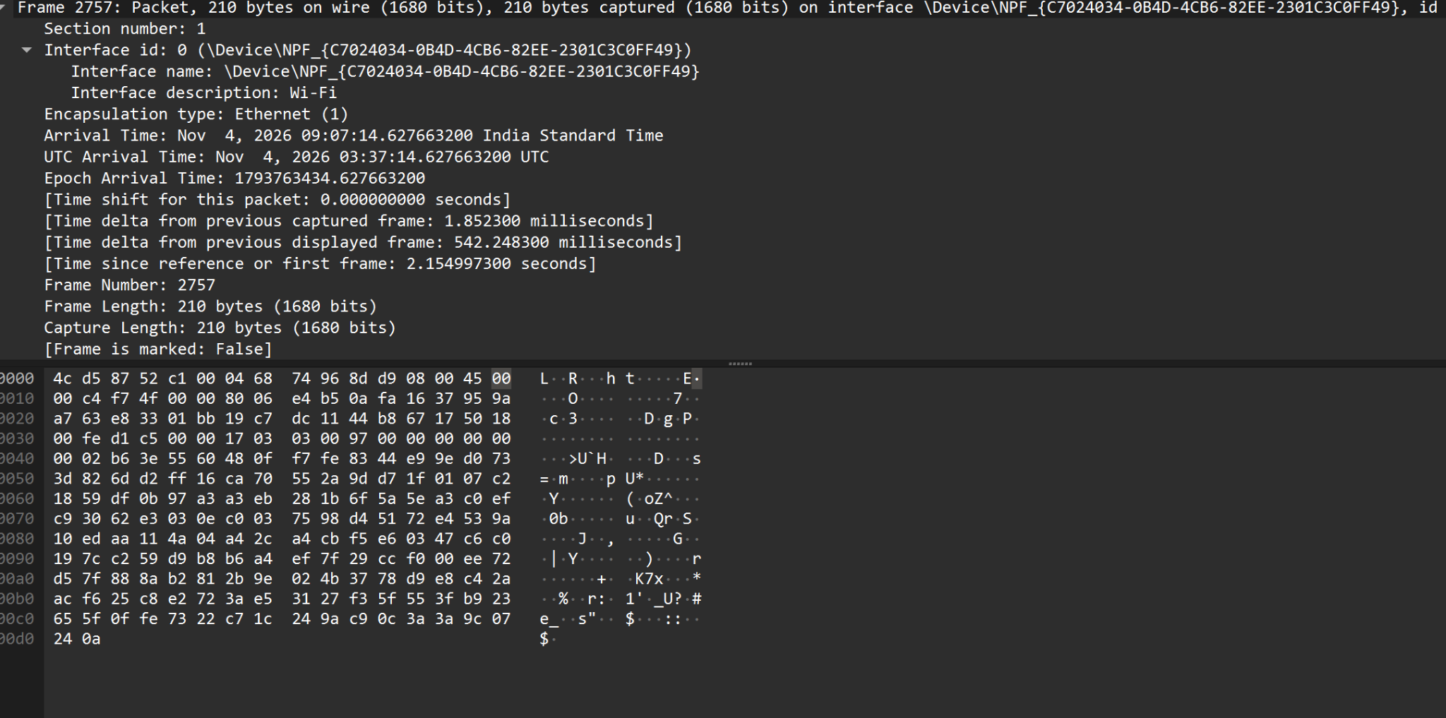
Figure D2. mDNS packet details and packet bytes.
Result: The supplied capture contains a UDP-based mDNS packet with source and destination port 5353. Its frame length is 136 bytes.

